Project Design Phase
Combined Design Document
Script-Controlled ACL – Restrict Record Access Based on Field Value
Team Member | Role
Afrin Fathima S | Team Lead
Adhithan S | Team Member
Abhishek Raja | Team Member
Ajith Kumar S S | Team Member

Date: 15 February 2025
Team ID:

Contents
- Problem - Solution Fit
- Proposed Solution Template
- Solution Architecture

Problem - Solution Fit
Define CS, fit into CC | CS | CC | AS | Explore AS, differentiate
1. CUSTOMER SEGMENT(S)  Who is your customer? i.e. working parents of 0-5 y.o. kids  - Organisations that run ServiceNow and hold sensitive records (e.g., Incidents) that only some departments may see  - Administrators and security managers who must protect the data  - Employees, service desk agents, department managers and auditors who work with the records | 6. CUSTOMER CONSTRAINTS  What constraints prevent your customers from taking action or limit their choices of solutions? i.e. spending power, budget, no cash, network connection, available devices.  - Limited scripting skills among administrators  - Fear of breaking existing access for other users  - Time and effort needed to test every user type  - Strict privacy and compliance expectations  - ACL changes need the security_admin role | 5. AVAILABLE SOLUTIONS  Which solutions are available to the customers when they face the problem or need to get the job done? What have they tried in the past? What pros & cons do these solutions have? i.e. pen and paper is an alternative to digital notetaking  - Role-based ACLs: simple, but cannot look at the content of a record  - Condition-only ACLs: no code, but limited for complex rules  - Query business rules: filter lists, but do not cover every access path by themselves  - Manual practice (separate tables, email, spreadsheets): slow and error-prone
Focus on J&P, tap into BE, understand RC  2. JOBS-TO-BE-DONE / PROBLEMS  Which jobs-to-be-done (or problems) do you address for your customers? There could be more than one; explore different sides.  - Allow a record to be opened only when a field value (e.g., Department) matches the user  - Keep restricted records hidden in lists, search, reports and API calls  - Let valid users and administrators keep working  - Give denied users a clear way to request access  - Prove that the restriction works | 9. PROBLEM ROOT CAUSE  What is the real reason that this problem exists? What is the back story behind the need to do this job? i.e. customers have to do it because of the change in regulations.  - Role-based access does not know what is inside a record  - Sensitive and ordinary records share the same table  - Privacy rules require that people see only what they need  - User attributes such as department change over time | Focus on J&P, tap into BE, understand RC  7. BEHAVIOUR  What does your customer do to address the problem and get the job done? i.e. directly related: find the right solar panel installer, calculate usage and benefits; indirectly associated: customers spend free time on volunteering work (i.e. Greenpeace)  - Administrators create ACLs, write scripts and test with impersonation  - Users work in lists and forms and ask the service desk or their manager when a record is missing  - Indirectly, users forward records by email or ask colleagues for copies
Identify strong TR & EM  3. TRIGGERS  What triggers customers to act? i.e. seeing their neighbour installing solar panels, reading about a more efficient solution in the news.  - An audit finding or compliance requirement  - A user seeing another department’s records by mistake  - A new department or sensitive process being added  - Reading best-practice guidance on access control | 10. YOUR SOLUTION  If you are working on an existing business, write down your current solution first, fill in the canvas, and check how much it fits reality. If you are working on a new business proposition, then keep it blank until you fill in the canvas and come up with a solution that fits within customer limitations, solves a problem and matches customer behaviour.  - A script-controlled read ACL that compares the record’s field value with the user’s attribute on the server  - Administrator and security roles bypass the check; everyone else is denied by default  - Same rule applies to lists, forms, search, reports and the REST API  - Access request and approval flow for denied users  - Denied attempts written to the log for auditors  - Rule tested with impersonation before activation | Extract online & offline CH of BE  8. CHANNELS of BEHAVIOUR - 8.1 ONLINE  What kind of actions do customers take online? Extract online channels from #7  - Administrators use the ACL form, script field, impersonation and Debug Security Rules  - Users open lists and forms in the web UI, Service Portal or mobile app and raise access requests online  - Teams read product documentation and community posts
4. EMOTIONS: BEFORE / AFTER  How do customers feel when they face a problem or a job and afterwards? i.e. lost, insecure > confident, in control - use it in your communication strategy & design.  - Before: worried, exposed, unsure why records are missing or visible  - After: confident, in control, clear on what to do next |  | 8.2 OFFLINE  What kind of actions do customers take offline? Extract offline channels from #7 and use them for customer development.  - Meetings with the data owner and security manager to agree the rule  - Verbal requests to a manager for access  - Policy documents and training for the service desk
Purpose / Vision

- Every record is visible only to the people who are entitled to see it, based on the data it holds.
Problem-Solution fit canvas is licensed under a Creative Commons Attribution-NonCommercial-NoDerivatives 4.0 license. Created by Daria Nepriakhina / Amaltama.com

Project Design Phase
Proposed Solution Template
Date | 15 February 2025
Team ID
Project Name | Script-Controlled ACL – Restrict Record Access Based on Field Value
Maximum Marks | 2 Marks
Proposed Solution Template:
Project team shall fill the following information in the proposed solution template.
S.No. | Parameter | Description
1. | Problem Statement (Problem to be solved) | In a ServiceNow instance, role-based access lets any user with the table role see every record in that table, even records that belong to another department or are sensitive.  The problem to solve is: Script-Controlled ACL – Restrict Record Access Based on Field Value, so that a record is visible only when the value in one of its fields matches the user.
2. | Idea / Solution description | Create a read ACL on the target table (e.g., Incident) whose script compares the record’s field value (e.g., Department) with the logged-in user’s attribute and returns true only when they match.  Administrator and security roles bypass the check, and any other user is denied by default.  The same rule applies to lists, forms, search, reports and the REST API. Denied users can raise an access request, a manager approves it, and denied attempts are logged for auditors.  The rule is tested by impersonating sample users before it is activated.
3. | Novelty / Uniqueness | One reusable script pattern protects every access path, instead of separate fixes for lists, forms and APIs.  The rule is driven by field values and user attributes, so new departments need no code change.  The solution closes the loop with a clear denial message, an access request and approval flow, and an audit log.
4. | Social Impact / Customer Satisfaction | Protects the privacy of employees’ and customers’ data by showing it only to people who need it.  Builds trust and supports compliance with privacy expectations.  Users understand why a record is hidden and know how to ask for access; administrators and auditors get evidence that the rule works.
5. | Business Model (Revenue Model) | As an internal security improvement, it needs no extra licence beyond the existing ServiceNow subscription.  If offered to other organisations as a service or reusable package, revenue can come from a one-time implementation fee and an annual support and maintenance subscription.
6. | Scalability of the Solution | The rule can be copied to other tables by pointing the ACL to a shared script include and changing the field name.  It runs inside the ServiceNow cloud platform, so it scales with the instance, and simple field comparisons keep the effect on performance small.

Project Design Phase
Solution Architecture
Date | 15 February 2025
Team ID
Project Name | Script-Controlled ACL – Restrict Record Access Based on Field Value
Maximum Marks | 4 Marks
Solution Architecture:
Solution architecture is a complex process – with many sub-processes – that bridges the gap between business problems and technology solutions. Its goals are to:
- Find the best tech solution to solve existing business problems.
- Describe the structure, characteristics, behavior, and other aspects of the software to project stakeholders.
- Define features, development phases, and solution requirements.
- Provide specifications according to which the solution is defined, managed, and delivered.

Solution Architecture Diagram:
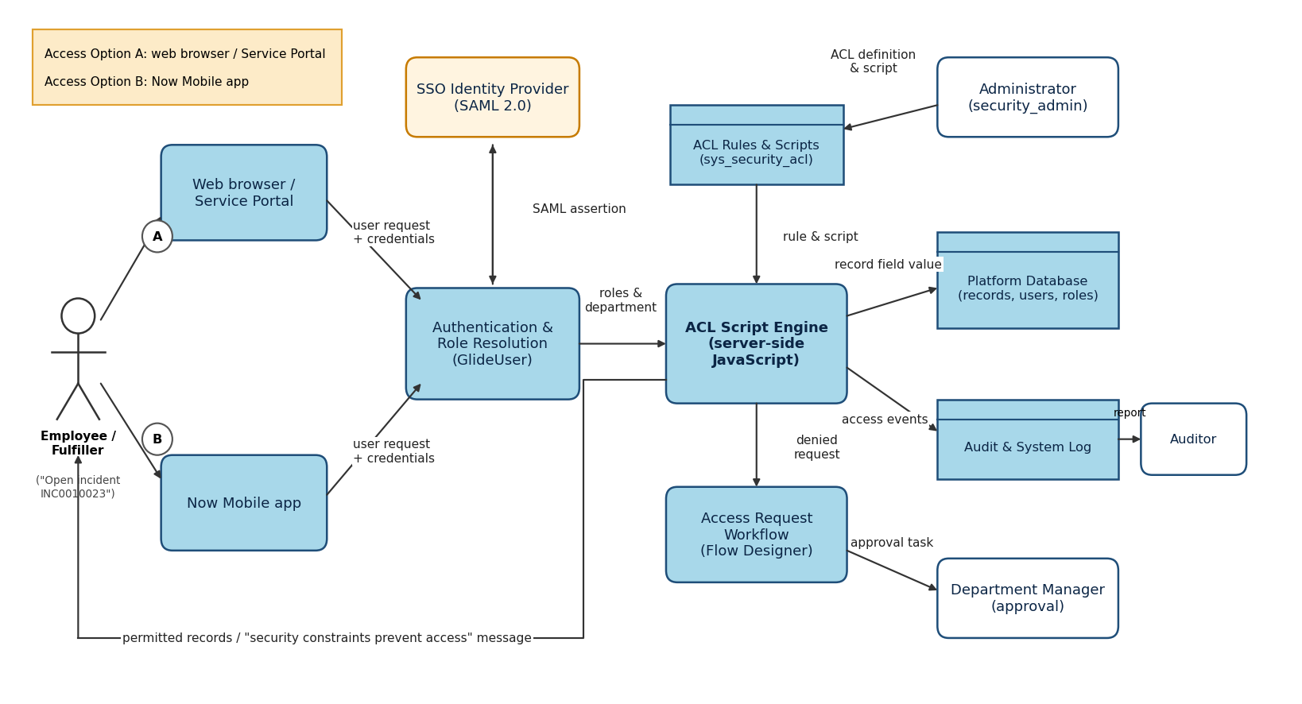
Figure 1: Architecture and data flow of the script-controlled ACL solution
Reference: ServiceNow product documentation on access control rules (docs.servicenow.com)
Data flow:
- The employee or fulfiller requests a record through the web browser / Service Portal (option A) or the Now Mobile app (option B).
- Authentication and role resolution confirms the user (optionally through the SSO identity provider) and reads the user’s roles and department.
- The ACL script engine reads the ACL rule and script and the record’s field value from the platform database, and decides allow or deny.
- Permitted records are returned to the user; otherwise a “security constraints prevent access” message is shown.
- Denied requests can start the access request workflow, which sends an approval task to the department manager.
- Access events are written to the audit and system log, which the auditor reviews.
- The administrator defines and maintains the ACL and its script.

